**Titanic Survival Prediction Final Report**

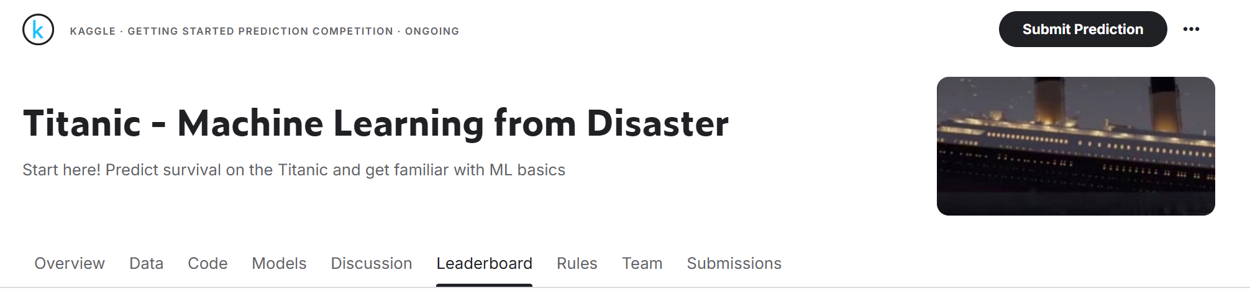**1. Main Objective of the Analysis**

The primary goal of this analysis is to build a **predictive model** to estimate the survival probability of passengers on the Titanic. Through this model, we aim to:

* **Optimize Rescue Resource Allocation**: Provide data-driven insights for prioritizing rescue efforts in future similar events.
* **Identify Key Survival Factors**: Understand how demographic features (e.g., gender, class) influence survival probability.
* **Enhance Model Interpretability**: Offer transparent insights into the drivers of survival for business decision-making.

**2. Dataset Description**

**Dataset Source**

The Titanic dataset from Kaggle (train.csv and test.csv) includes training data for 891 passengers and test data for 418 passengers.

**Key Features**

* **Target Variable**: Survived (0 = Did Not Survive, 1 = Survived).

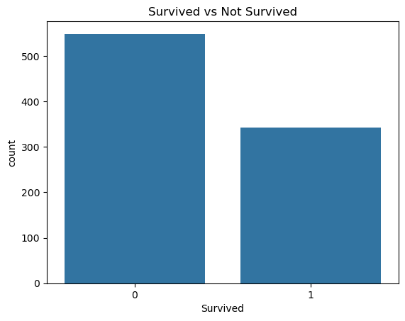

* **Input Features**:
  + Demographic: Sex (gender), Age (age).
  + Socioeconomic Status: Pclass (ticket class, 1st/2nd/3rd class).
  + Family Structure: SibSp (number of siblings/spouses), Parch (number of parents/children).
  + Other: Fare (ticket fare), Embarked (port of embarkation).

**Analysis Goal**

To predict passenger survival probability using machine learning models and identify key factors influencing survival.

**3. Data Exploration and Cleaning**

**Data Exploration**

* **Survival Rate**: Approximately 38% of passengers survived (see Figure 1).
* **Key Feature Distributions**:
  + Females had a significantly higher survival rate than males (74% vs. 19%).
  + First-class passengers had a much higher survival rate (63%) compared to third-class passengers (24%).

**Data Cleaning and Feature Engineering**

1. **Handling Missing Values**:
   * Age: Filled with the median value.
   * Embarked: Filled with the most frequent value (S port).
   * Cabin: Dropped due to a high percentage of missing values.
2. **Creating New Features**:
   * FamilySize: Family size (SibSp + Parch + 1).
   * IsAlone: Whether the passenger was traveling alone (FamilySize == 1).
3. **Removing Redundant Features**: Dropped irrelevant features such as PassengerId, Name, and Ticket.

**4. Model Training and Evaluation**

We trained three different classifiers, ensuring consistency through **5-Fold Cross-Validation**:

**Model 1: Logistic Regression**

* **Characteristics**: High interpretability, serves as a strong baseline model.
* **Strengths**: Fast computation, effective for linearly separable data, and provides clear insights into feature importance.
* **Weaknesses**: Struggles with capturing nonlinear relationships and complex interactions.

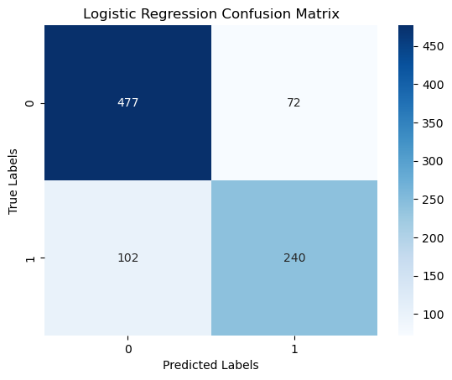

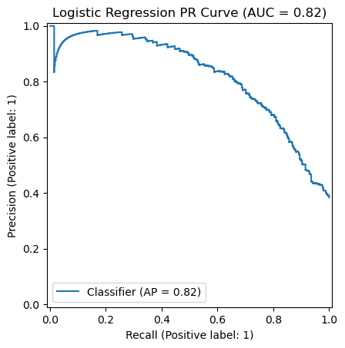

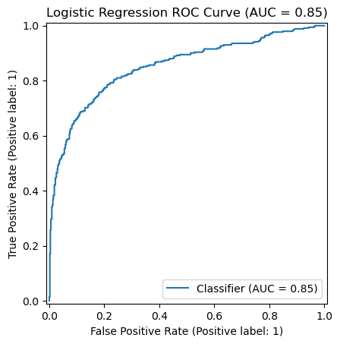

**Model 2: Decision Tree**

* **Characteristics**: Simple, interpretable, and capable of handling nonlinear relationships.
* **Strengths**: Automatically selects key features and is not sensitive to feature scaling.
* **Weaknesses**: Prone to overfitting, leading to poor generalization.

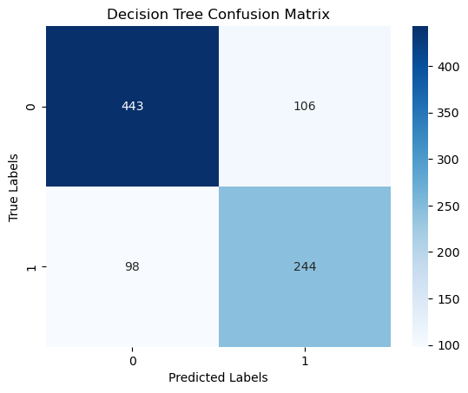

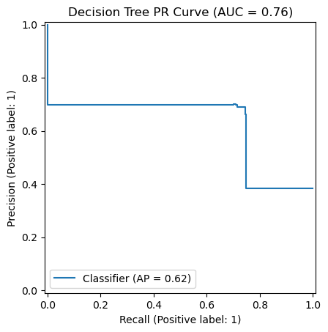

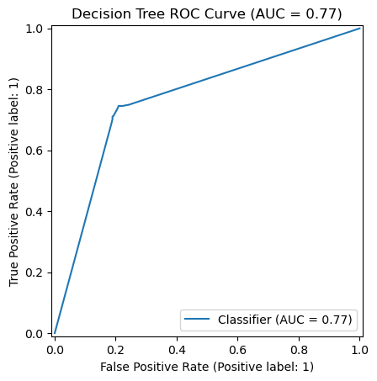

**Model 3: Random Forest**

* **Characteristics**: An ensemble method that balances predictive performance and interpretability.
* **Strengths**: Reduces overfitting compared to a single decision tree, provides feature importance scores.
* **Weaknesses**: Higher computational cost and less interpretable than logistic regression.

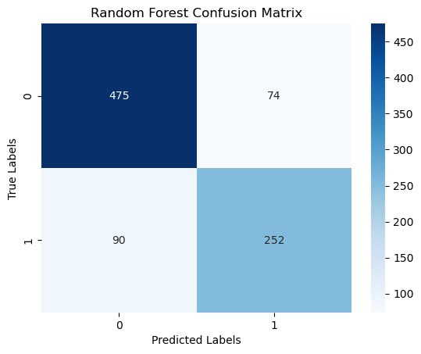

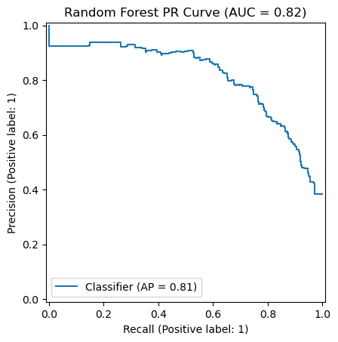

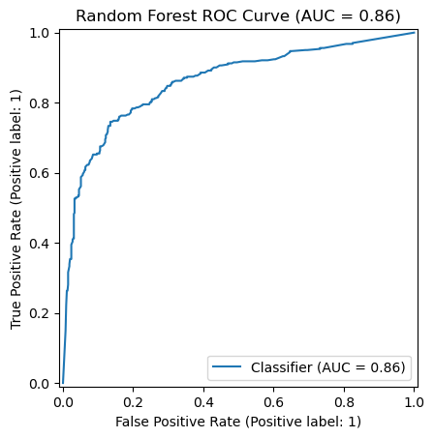

**Model 4: Gradient Boosting**

* **Characteristics: An ensemble method that builds models sequentially, improving prediction accuracy at each step.**
* **Strengths: High predictive performance, captures complex patterns, and reduces bias by focusing on hard-to-predict instances.**
* **Weaknesses: Can be prone to overfitting with noisy data, requires careful tuning of hyperparameters, and has higher computational costs.**

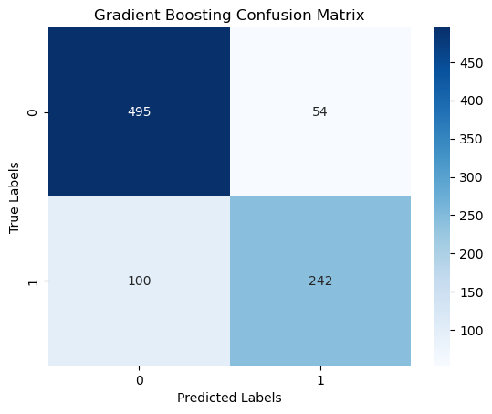

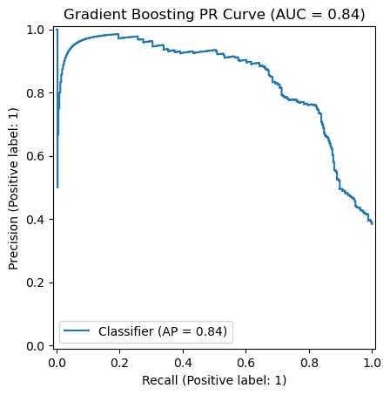

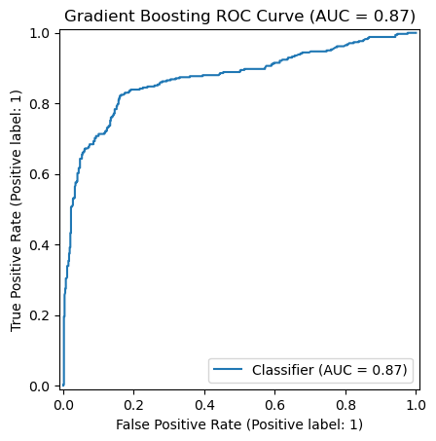

**Model 5: LightGBM**

* **Characteristics: A gradient boosting variant optimized for efficiency.**
* **Strengths: Fast training, effective for large datasets, and captures complex patterns.**
* **Weaknesses: Can overfit on small datasets, sensitive to hyperparameter tuning.**

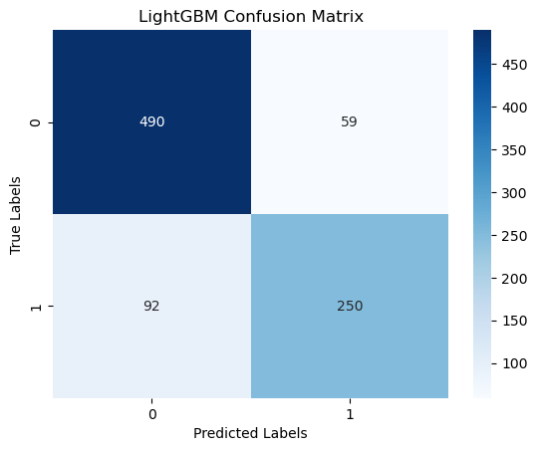

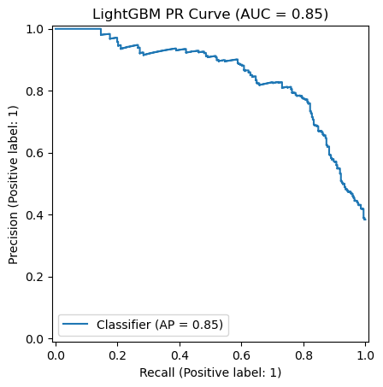

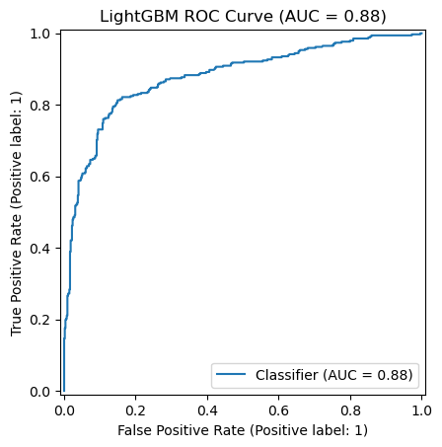

**Model 6: CatBoost**

* **Characteristics**: A gradient boosting model optimized for categorical features.
* **Strengths**: Handles categorical data efficiently, reduces preprocessing needs, and is robust to missing values.
* **Weaknesses**: Slower training time, may not significantly outperform other boosting models on small datasets.

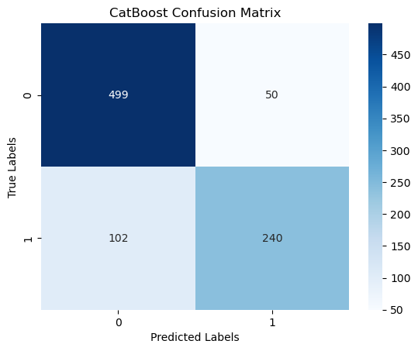

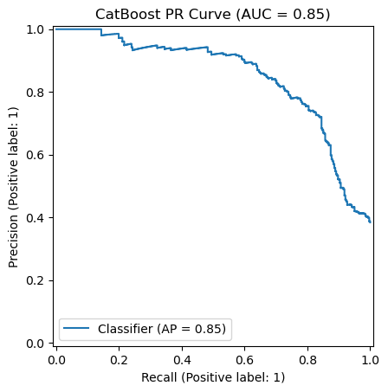

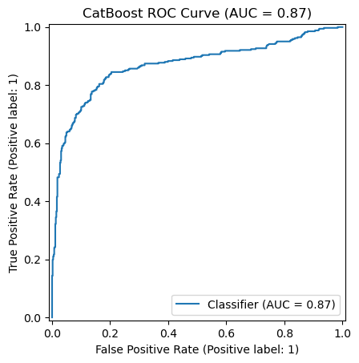

**Model 7: K-Nearest Neighbors (KNN)**

* **Characteristics**: A non-parametric model based on proximity to labeled samples.
* **Strengths**: Simple and intuitive, requires no explicit training phase.
* **Weaknesses**: Computationally expensive, struggles with high-dimensional and imbalanced data.

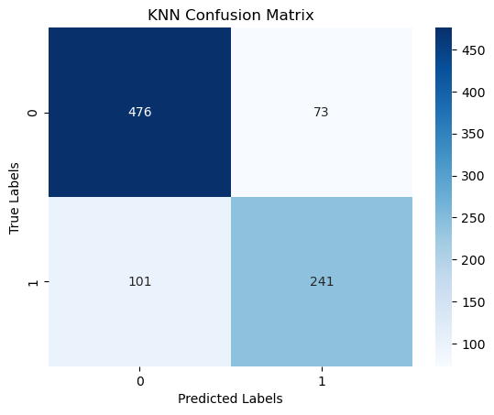

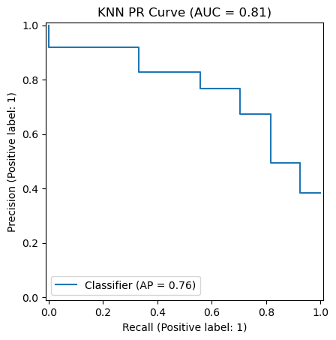

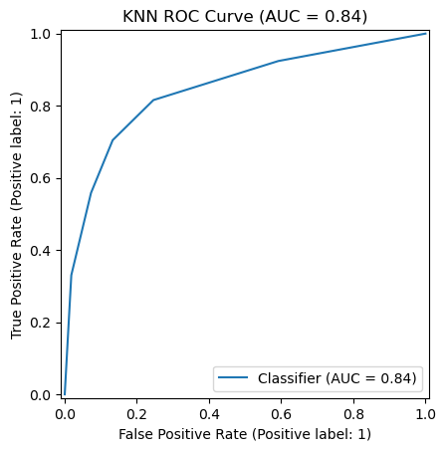

**Model 8: Support Vector Machine (SVM)**

* **Characteristics**: A powerful classification algorithm that constructs an optimal hyperplane.
* **Strengths**: Works well with high-dimensional data, effective in small datasets.
* **Weaknesses**: Computationally expensive, especially with large datasets, and requires careful tuning of kernel parameters.

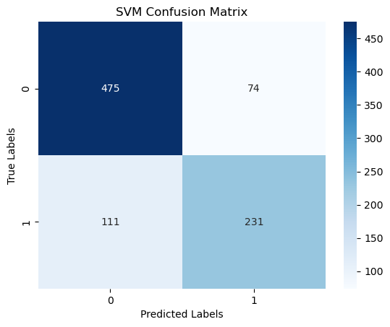

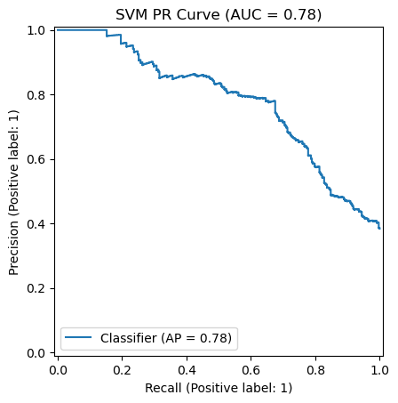

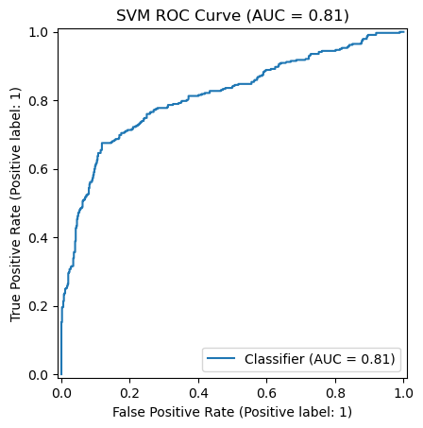

**5. final Kaggle score**

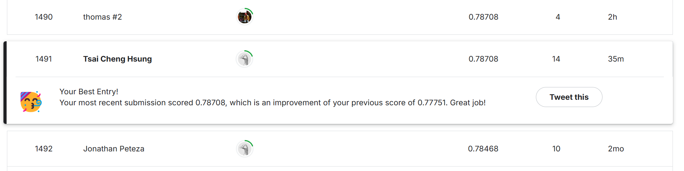

**6. Key Findings and Insights**

1. **Gender and Class Are Core Survival Drivers**:
   * Females were 3.9 times more likely to survive than males.
   * First-class passengers were 2.6 times more likely to survive than third-class passengers.
2. **Impact of Family Structure**:
   * Passengers traveling alone (IsAlone=1) had a lower survival rate (30% vs. 50%).
3. **Non-linear Impact of Age**:
   * Children (<10 years) had a higher survival rate, while adult males had the lowest survival rate.

**7. Future**

1. **Data Enhancement**:
   * Collect detailed Cabin information to improve feature granularity.
   * Add passenger occupation or social status data (e.g., titles like Mr/Mrs).
2. **Model Optimization**:
   * Experiment with neural networks to capture more complex interactions.